Certificate of Registration

This is to certify that
Klinger Limited
Is now a registered supplier in the Achilles Power & Tech Community, and that company information related to the following criteria has been checked and validated by Achilles Information Limited, an independent third party:
- Supply Chain Management
- Corporate Social Responsibility
- Health & Safety Management
- Quality Management
- Environmental Management
- Carbon Management
- Financial & Insurance
- Information Security & Data Protection

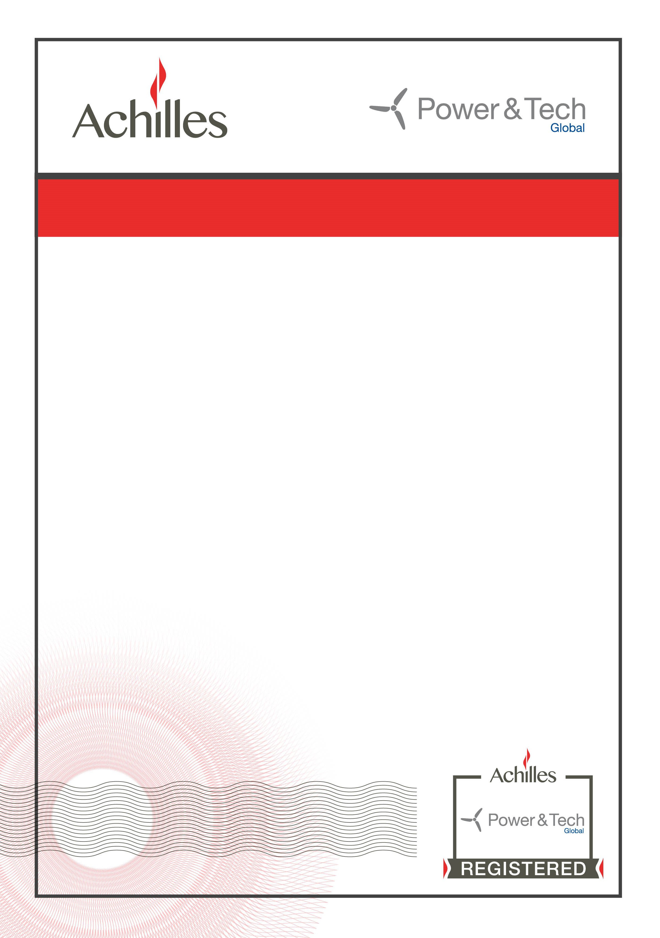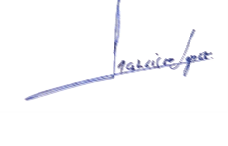Supplier ID: 198891

Expiry Date: 21 December 2019
Francisco Lopez Power & Tech Community Director Achilles Information Limited

Registered Products/Services

Product/Service Code and Description

1.1.4 Fasteners & Fixings
1.19.22 Rubber
3.14.2 Mechanical Seals & Gaskets

